

**Faculty of engineering - Shoubra Benha University**

# Research Article / Research Project / Literature Review

in fulfillment of the requirements of

|  |  |
| --- | --- |
| **Department** | **Engineering Mathematics and Physics** |
| **Division** |  |
| **Academic Year** | **2019-2020 Preparatory** |
| **Course name** | **Computer** |
| **Course code** | **ECE001** |

**Title: -**

**Artificial Intelligence**

By:

|  |  |  |  |
| --- | --- | --- | --- |
|  | Name | Edu mail | B.N |
| 1 | ديفيد بديع رياض عزيز | [daivid195365@feng.bu.edu.eg](mailto:daivid195365@feng.bu.edu.eg) | 334 |

## Approved by:

|  |  |
| --- | --- |
| Examiners committee | Signature |
|  |  |
|  |  |
|  |  |
|  |  |
|  |  |

**Research objectives**

## What Is Artificial Intelligence (AI)?

Artificial intelligence (AI) refers to the simulation of human intelligence in machines that are programmed to think like humans and mimic their actions. The term may also be applied to any machine that exhibits traits associated with a human mind such as learning and problem-solving.

The ideal characteristic of artificial intelligence is its ability to rationalize and take actions that have the best chance of achieving a specific goal.

## Understanding Artificial Intelligence:

When most people hear the term artificial intelligence, the first thing they usually think of is robots. That's because big-budget films and novels weave stories about human-like machines that wreak havoc on Earth. But nothing could be further from the truth.

Artificial intelligence is based on the principle that human intelligence can be defined in a way that a machine can easily mimic it and execute tasks, from the most simple to those that are even more complex. The goals of artificial intelligence include learning, reasoning, and perception.

As technology advances, previous benchmarks that defined artificial intelligence become outdated. For example, machines that calculate basic functions or recognize text through optimal character recognition are no longer considered to embody artificial intelligence, since this function is now taken for granted as an inherent computer function.

AI is continuously evolving to benefit many different industries. Machines are wired using a cross-disciplinary approach based in mathematics, computer science, linguistics, psychology, and more.

# Abstract

# Artificial intelligence (AI) is the simulation of human intelligence  processes by machines, especially computer systems. Specific applications of AI include expert systems, natural language processing (NLP), speech recognition and machine vision.

AI programming focuses on three cognitive skills: learning, reasoning and self-correction.

**Learning processes.** This aspect of AI programming focuses on acquiring data and creating rules for how to turn the data into actionable information. The rules, which are called algorithms, provide computing devices with step-by-step instructions for how to complete a specific task.

**Reasoning processes.** This aspect of AI programming focuses on choosing the right algorithm to reach a desired outcome.

**Self-correction processes.** This aspect of AI programming is designed to continually fine-tune algorithms and ensure they provide the most accurate results possible.

# Table of contents

|  |  |
| --- | --- |
| **Subject / section** | **Page** |
| Research Objectives | 1 |
| Abstract | 2 |
| Introduction | 6 |
| Literature Review | 8 |
| Results and Discussion | 13 |
| Conclusion | 15 |

# List of Figures (If any)

|  |  |  |
| --- | --- | --- |
| **Figure I.D** | **Description** | **Page** |
|  | Artificial Intelligence | 6 |
|  | Types of AI | 12 |
|  | Comparison between AI and HI | 15 |
|  |  |  |
|  |  |  |
|  |  |  |

**List of Tables (If any)**

|  |  |  |
| --- | --- | --- |
| **Table I.D** | **Description** | **Page** |
|  |  |  |
|  |  |  |
|  |  |  |
|  |  |  |
|  |  |  |
|  |  |  |

**Introduction**

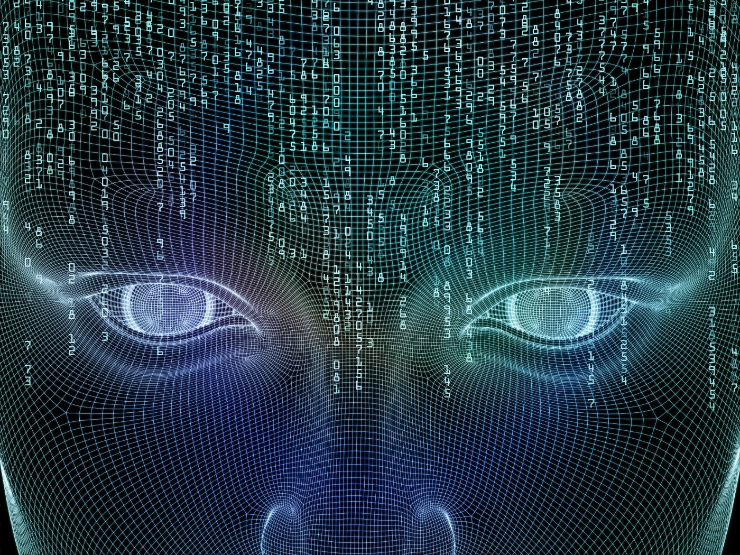

In computer science, artificial intelligence (AI), sometimes called machine intelligence, is intelligence demonstrated by machines, in contrast to the natural intelligence displayed by humans and animals. Leading AI textbooks define the field as the study of "intelligent agents": any device that perceives its environment and takes actions that maximize its chance of successfully achieving its goals. Colloquially, the term "artificial intelligence" is often used to describe machines (or computers) that mimic "cognitive" functions that humans associate with the human mind, such as "learning" and "problem solving".

As machines become increasingly capable, tasks considered to require "intelligence" are often removed from the definition of AI, a phenomenon known as the AI effect. A quip in Tesler's Theorem says "AI is whatever hasn't been done yet." For instance, optical character recognition is frequently excluded from things considered to be AI, having become a routine technology.Modern machine capabilities generally classified as AI include successfully understanding human speech,competing at the highest level in strategic game systems (such as chess and Go), autonomously operating cars, intelligent routing in content delivery networks, and military simulations.

Artificial intelligence was founded as an academic discipline in 1955, and in the years since has experienced several waves of optimism, followed by disappointment and the loss of funding .For most of its history, AI research has been divided into sub-fields that often fail to communicate with each other. These sub-fields are based on technical considerations, such as particular goals (e.g. "robotics" or "machine learning"), the use of particular tools ("logic" or artificial neural networks), or deep philosophical differences. Sub-fields have also been based on social factors (particular institutions or the work of particular researchers).

The traditional problems (or goals) of AI research include reasoning, knowledge representation, planning, learning, natural language processing, perception and the ability to move and manipulate objects.General intelligence is among the field's long-term goals. Approaches include statistical methods, computational intelligence, and traditional symbolic AI. Many tools are used in AI, including versions of search and mathematical optimization, artificial neural networks, and methods based on statistics, probability and economics. The AI field draws upon computer science, information engineering, mathematics, psychology, linguistics, philosophy, and many other fields.

The field was founded on the assumption that human intelligence "can be so precisely described that a machine can be made to simulate it".This raises philosophical arguments about the nature of the mind and the ethics of creating artificial beings endowed with human-like intelligence. These issues have been explored by myth, fiction and philosophy since antiquity. Some people also consider AI to be a danger to humanity if it progresses unabated.Others believe that AI, unlike  previous technological revolutions, will create a risk of mass unemployment

In the twenty-first century, AI techniques have experienced a resurgence following concurrent advances in computer power, large amounts of data, and theoretical understanding; and AI techniques have become an essential part of the technology industry, helping to solve many challenging problems in computer science, software engineering and operations research.

# Literature Review

**1-HOW DOES ARTIFICIAL INTELLIGENCE WORK?**

*Can machines think? — Alan Turing, 1950*

Less than a decade after breaking the Nazi encryption machine Enigma and helping the Allied Forces win World War II, mathematician Alan Turing changed history a second time with a simple question: "Can machines think?"

Turing's paper "[Computing Machinery and Intelligence](https://www.csee.umbc.edu/courses/471/papers/turing.pdf)" (1950), and it's subsequent Turing Test, established the fundamental goal and vision of artificial intelligence.

At it's core, AI is the branch of computer science that aims to answer Turing's question in the affirmative. It is the endeavor to replicate or simulate human intelligence in machines.

The expansive goal of artificial intelligence has given rise to many questions and debates. So much so, that no singular definition of the field is universally accepted.

The major limitation in defining AI as simply "building machines that are intelligent" is that it doesn't actually explain what artificial intelligence is? What makes a machine intelligent?

In their groundbreaking textbook Artificial Intelligence: A Modern Approach, authors Stuart Russell and Peter Norvig approach the question by unifying their work around the theme of intelligent agents in machines. With this in mind, AI is "the study of agents that receive percepts from the environment and perform actions." (Russel and Norvig viii)

Norvig and Russell go on to explore four different approaches that have historically defined the field of AI:

1. **Thinking humanly**
2. **Thinking rationally**
3. **Acting humanly**
4. **Acting rationally**

The first two ideas concern thought processes and reasoning, while the others deal with behavior. Norvig and Russell focus particularly on rational agents that act to achieve the best outcome, noting "all the skills needed for the Turing Test also allow an agent to act rationally." (Russel and Norvig 4).

Patrick Winston, the Ford professor of artificial intelligence and computer science at MIT, [defines AI](https://ocw.mit.edu/courses/electrical-engineering-and-computer-science/6-034-artificial-intelligence-fall-2010/lecture-videos/lecture-1-introduction-and-scope/) as  "algorithms enabled by constraints, exposed by representations that support models targeted at loops that tie thinking, perception and action together."

"AI is a computer system able to perform tasks that ordinarily require human intelligence... Many of these artificial intelligence systems are powered by machine learning, some of them are powered by deep learning and some of them are powered by very boring things like rules."

**2-HOW IS AI USED?**

Artificial intelligence generally falls under two broad categories:

* **Narrow AI:** Sometimes referred to as "Weak AI," this kind of artificial intelligence operates within a limited context and is a simulation of human intelligence. Narrow AI is often focused on performing a single task extremely well and while these machines may seem intelligent, they are operating under far more constraints and limitations than even the most basic human intelligence.
* **Artificial General Intelligence (AGI)**: AGI, sometimes referred to as "Strong AI," is the kind of artificial intelligence we see in the movies, like the robots from Westworld or Data from Star Trek: The Next Generation. AGI is a machine with general intelligence and, much like a human being, it can apply that intelligence to solve any problem.

## Narrow Artificial Intelligence:

Narrow AI is all around us and is easily the most successful realization of artificial intelligence to date. With its focus on performing specific tasks, Narrow AI has experienced numerous breakthroughs in the last decade that have had "significant societal benefits and have contributed to the economic vitality of the nation," according to "Preparing for the Future of Artificial Intelligence," a 2016 report released by the Obama Administration.

A few examples of Narrow AI include:

* Google search
* Image recognition software
* Siri, Alexa and other personal assistants
* Self-driving cars
* IBM's Watson

### Machine Learning & Deep Learning

Much of Narrow AI is powered by breakthroughs in [machine learning](https://www.expertsystem.com/machine-learning-definition/) and [deep learning](https://www.mathworks.com/discovery/deep-learning.html). Understanding the difference between artificial intelligence, machine learning and deep learning can be confusing. Venture capitalist Frank Chen [provides a good overview](https://a16z.com/2016/06/10/ai-deep-learning-machines/) of how to distinguish between them, noting:

*"Artificial intelligence is a set of algorithms and intelligence to try to mimic human intelligence. Machine learning is one of them, and deep learning is one of those machine learning techniques."*

Simply put, machine learning feeds a computer data and uses statistical techniques to help it "learn" how to get progressively better at a task, without having been specifically programmed for that task, eliminating the need for millions of lines of written code. Machine learning consists of both supervised learning (using labeled data sets) and unsupervised learning (using unlabeled data sets).

Deep learning is a type of machine learning that runs inputs through a biologically-inspired neural network architecture. The neural networks contain a number of hidden layers through which the data is processed, allowing the machine to go "deep" in its learning, making connections and weighting input for the best results.

## Artificial General Intelligence

The creation of a machine with human-level intelligence that can be applied to any task is the Holy Grail for many AI researchers, but the quest for AGI has been fraught with difficulty.

The search for a "universal algorithm for learning and acting in any environment," (Russel and Norvig 27) isn't new, but time hasn't eased the difficulty of essentially creating a machine with a full set of cognitive abilities.

AGI has long been the muse of dystopian science fiction, in which super-intelligent robots overrun humanity, but experts agree it's not something we need to worry about [anytime soon](https://obamawhitehouse.archives.gov/sites/default/files/whitehouse_files/microsites/ostp/NSTC/preparing_for_the_future_of_ai.pdf).

## 3-Special Considerations:

Since its beginning, artificial intelligence has come under scrutiny from scientists and the public alike. One common theme is the idea that machines will become so highly developed that humans will not be able to keep up and they will take off on their own, redesigning themselves at an exponential rate.

Another is that machines can hack into people's privacy and even be weaponized. Other arguments debate the ethics of artificial intelligence and whether intelligent systems such as robots should be treated with the same rights as humans.

Self-driving cars have been fairly controversial as their machines tend to be designed for the lowest possible risk and the least casualties. If presented with a scenario of colliding with one person or another at the same time, these cars would calculate the option that would cause the least amount of damage.

Another contentious issue many people have with artificial intelligence is how it may affect human employment. With many industries looking to automate certain jobs through the use of intelligent machinery, there is a concern that people would be pushed out of the workforce. Self-driving cars may remove the need for taxis and car-share programs, while manufacturers may easily replace human labor with machines, making people's skills more obsolete.

## 4-Applications of Artificial Intelligence:

The applications for artificial intelligence are endless. The technology can be applied to many different sectors and industries. AI is being tested and used in the healthcare industry for dosing drugs and different treatment in patients, and for surgical procedures in the operating room.

Other examples of machines with artificial intelligence include computers that play chess and self-driving cars. Each of these machines must weigh the consequences of any action they take, as each action will impact the end result. In chess, the end result is winning the game. For self-driving cars, the computer system must account for all external data and compute it to act in a way that prevents a collision.

Artificial intelligence also has applications in the financial industry, where it is used to detect and flag activity in banking and finance such as unusual debit card usage and large account deposits—all of which help a bank's fraud department. Applications for AI are also being used to help streamline and make trading easier. This is done by making supply, demand, and pricing of securities easier to estimate.

**Four Types of Artificial Intelligence:**

Arend Hintze, an assistant professor of integrative biology and computer science and engineering at Michigan State University, explained in a 2016 article that AI can be categorized into four types, beginning with the task-specific intelligent systems in wide use today and progressing to sentient systems, which do not yet exist. The categories are as follows:

* **Type 1: Reactive machines.** These AI systems have no memory and are task specific. An example is Deep Blue, the IBM chess program that beat Garry Kasparov in the 1990s. Deep Blue can identify pieces on the chessboard and make predictions, but because it has no memory, it cannot use past experiences to inform future ones.
* **Type 2: Limited memory.** These AI systems have memory, so they can use past experiences to inform future decisions. Some of the decision-making functions in self-driving cars are designed this way.
* **Type 3: Theory of mind.** Theory of mind is a psychology term. When applied to AI, it means that the system would have the social intelligence to understand emotions. This type of AI will be able to infer human intentions and predict behavior, a necessary skill for AI systems to become integral members of human teams.
* **Type 4:** **Self-awareness.** In this category, AI systems have a sense of self, which gives them consciousness. Machines with self-awareness understand their own current state. This type of AI does not yet exist.

[View All Jobs](https://builtin.com/jobs)

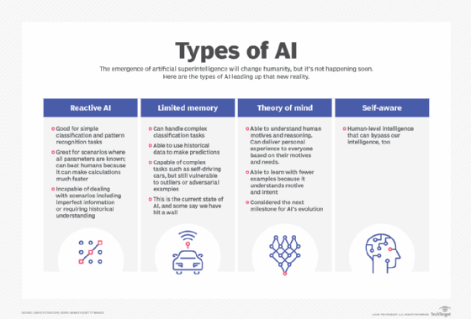

# Results and discussion

**1-Artificial Intelligence will create new jobs**:

Some believe that AI can create even more new jobs than ever before. According to this school of thought, AI will be the most significant job engine the world has ever seen. Artificial intelligence will eliminate low-skilled jobs and effectively create massive high-skilled job opportunities that will span all sectors of the economy.

For example, if AI becomes fully adapt to language translation, it will create a considerable demand for high-skilled human translators. If the costs of essential translations drop to nearly zero, this will encourage MORE companies that need this particular service to expand their business operations abroad.

To those who speak different languages than the community in which they reside, this help will inevitably create more work for high-skilled translators, boost more economic activities. As a result of this, and more people will be employed in these companies due to the increased workload.

Boosting international trade it one of the most significant benefits of our “global” times. So yes, AI will eliminate some jobs, but it will create many, many more.

## 2-Artificial Intelligence will eliminate the need for you to perform tedious tasks:

AI is changing the workplace, and there are plenty of reasons to be optimistic. It is used to do lots of tedious and lengthy tasks, especially the low-skilled types of jobs that are labor-intensive. It means that employees will be retasked away from boring jobs and bring significant and positive change in the workplace.

For instance, artificial intelligence is used in the automotive industry to do repetitive tasks such as performing a routine operation in the assembly line, for example. Allowing a robot to care for well, robotic-tasks, has created a shift in the workforce.

## 3-AI is used to increase auto safety and decrease traffic complications:

Auto accidents are one of the most popular types of accidents that happen in America. It kills thousands of people annually. A whopping 95 percent of these accidents are caused by human error, meaning accidents are avoidable.

The number of accident cases will reduce as artificial intelligence is being introduced into the industry by the use of self-driving cars. On-going research in the auto industry is looking at ways AI can be used to improve traffic conditions.

Smart systems are currently in place in many cities that are used to analyze traffic lights at the intersection. Avoiding congestion leads to safer movements of vehicles, bicycles, and pedestrians.

# Conclusions

Artificial intelligence is very useful in all industries as more research is being done to advance it. The advancements in this AI tech will be most useful if it is understood and trusted. An important part of it is that artificial intelligence and related technologies such as drones, robots, and autonomous vehicles can create around tens of millions of jobs over the next decade.

Having more jobs created — not less — will be great news for everyone. More jobs will help boost the GDP of the economy. Advancement in AI and its impressive computational power has already led to the concept of supercomputers and beyond.

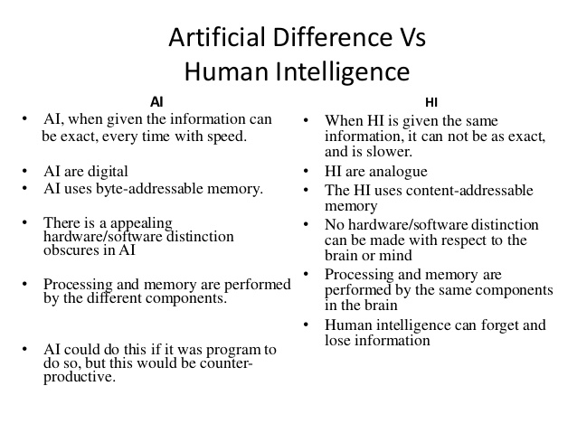

# References

# 1-<https://builtin.com/artificial-intelligence>

# 2-<https://www.investopedia.com/terms/a/artificial-intelligence-ai.asp>

# 3- <https://searchenterpriseai.techtarget.com/definition/AI-Artificial-Intelligence>

# 4- <https://readwrite.com/2019/10/09/5-reasons-why-artificial-intelligence-is-important-to-you/>

**Screenshots:**

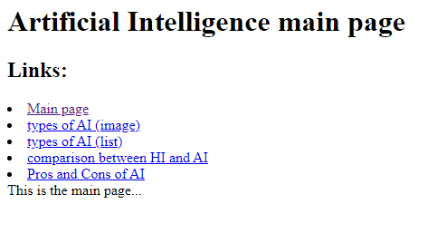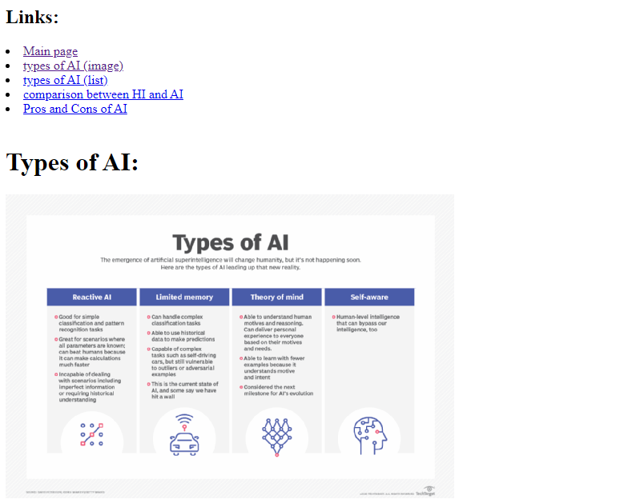

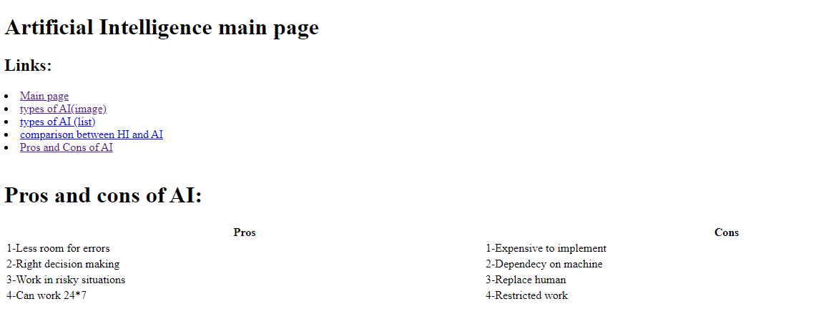

**Source code:**

